SAP Application Development

(S/4 HANA)

ABAP Lock Concept

Content  This chapter is about the ABAP lock concept. You will learn how to use a previously defined lock object to ensure data consistency even with multiple concurrent write operations on the same data set. | Prerequisites  You should be familiar with ABAP and principles of ABAP Objects with database access. Besides, it is necessary to have experience SAP GUI and Eclipse navigation. For this, you should have completed the chapter Introduction to SAP Programming.
Motivation  Since shared data resources and operational concurrency using multiple applications simultaneously is state-of-the-art today, it is necessary to apply the concept of locks to guarantee data consistency. This chapter is an excellent introduction to learn how to use lock objects for SAP applications. | Lecture notes  Fundamental knowledge about database access for ABAP programs and principles in both ABAP and ABAP Objects development is a prerequisite for the students. Students can go on with their account from the previous chapters.

- Product: All

- Level: Advanced

- Focus: Programming

- Version: 2.0

- Author: UCC Technical University of Munich

Task 1: Login into the SAP system within Eclipse
Short description: Use Eclipse to login into the SAP system with your username and password
Login

Start Eclipse and select the local workspace where your ABAP project is stored.

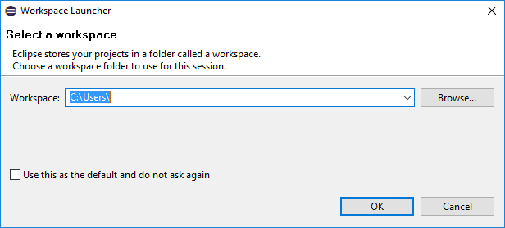

Please refer to the local workspace of Module “Dynamic Programs” where you learned how to access and work on data sets from the database. If you haven’t finished the exercise from Module “Dynamic Programs”, please do it now before you continue with this one.

Task 2: Usage of lock object
Short description: Use lock objects in your program from Module “Dynamic Programs” to avoid data inconsistency when changing connection details

At first you want to have a look on the lock object itself. Please open the following path within the Project Explorer to access the dictionary information of the lock object ‘ESFLIGHT’:
Package path

System Library • S_NWDEMO_BASIS • SAPBC_MAIN • SAPBC_GLOBAL • Dictionary • Lock Objects • ESFLIGHT

ESFLIGHT
The system comes up with the details about the lock objects. Switch to the tab ‘Lock parameter’ and have a look on the lock parameter. You see that the lock object uses the primary key of the table ‘SFLIGHT’ to lock data sets in the table.
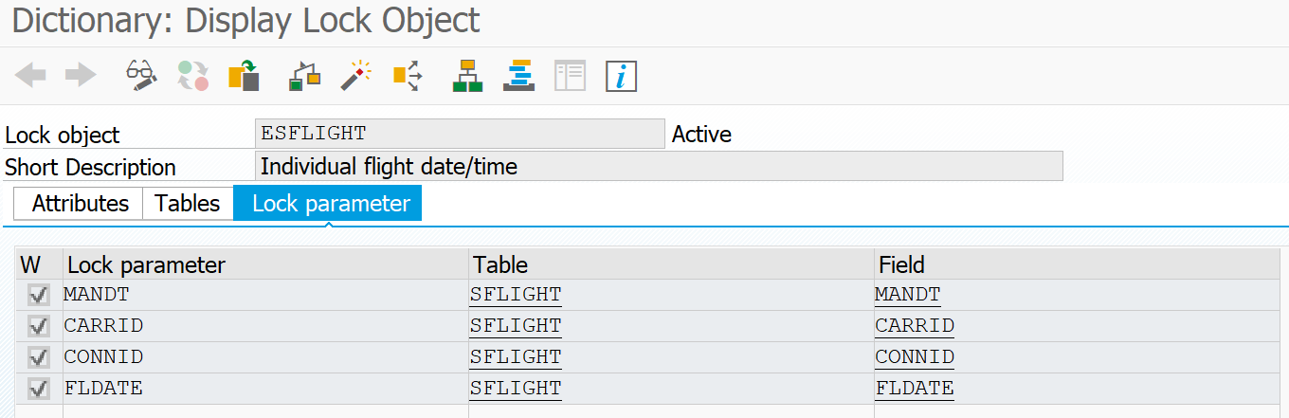

Important hint
Important Hint:
Please note that customer lock objects are bound to a namespace too. Name all of your custom lock objects to EZ_<table name>. You can create a new lock object after you created the table to which it belongs.

Call Function
Call Function
Ctrl + Space
Call Function
Shift + Enter
Now you want to use a lock object in your program from the previous module. The ideal way to use it is to implement two locks: one shared lock when reading the data from the table ‘SPFLI’ and one exclusive lock when writing the data to table ‘SPFLI’. You start with the shared lock in ‘USER_COMMAND_0100’. Please refer to the previous program called Z_$$_###_DYNPRO and open the module. The module is listed in the folder ‘PAI Modules’. Add the shared lock just in front of the ‘SELECT’ statement - to do so place the cursor before the ‘SELECT’ statement, type in CALL FUNCTION ‘ENQUEUE_ESSP and press Ctrl + Space on your keyboard to call the auto completion popup.

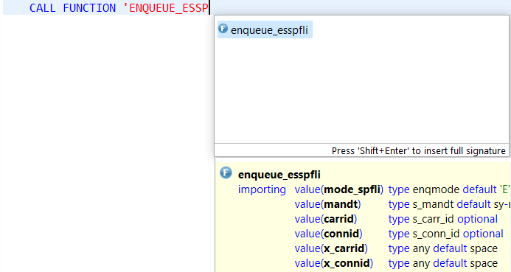

Select enqueue_esspfli and press Shift + Enter as proposed in one of the popup windows on your keyboard to retrieve all necessary parameters from the system automatically.

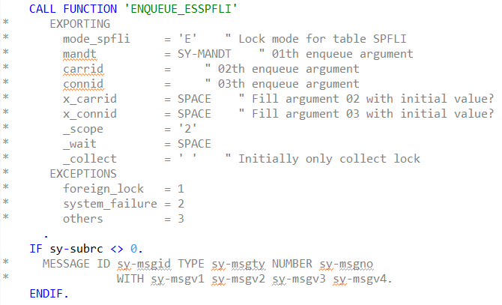

To use it properly you have to modify the function call at first. Please use the following example:
Source code

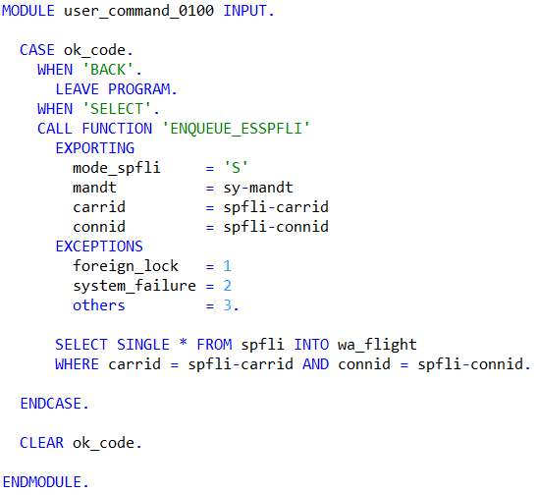

Save, check, activate
To call the enqueue function you have to use the current selected ‘CARRID’ and ‘CONNID’ from your structure ‘SPFLI’. Moreover you have to specify the type of lock (‘S’ for shared lock) and the current client (this is read from system variable ‘SY-MANDT’). Save, check and activate your module.

USER_COMMAND_0200
This shared lock will be released right after the user clicks a button in the second screen of your program. Hence, please open your ‘USER_COMMAND_0200’ module. The shared lock will be released shortly before the case instruction. Place the cursor before the case instruction, type in CALL FUNCTION ‘DEQUEUE_ESSP and press Control + Space on your keyboard to call the auto completion popup.

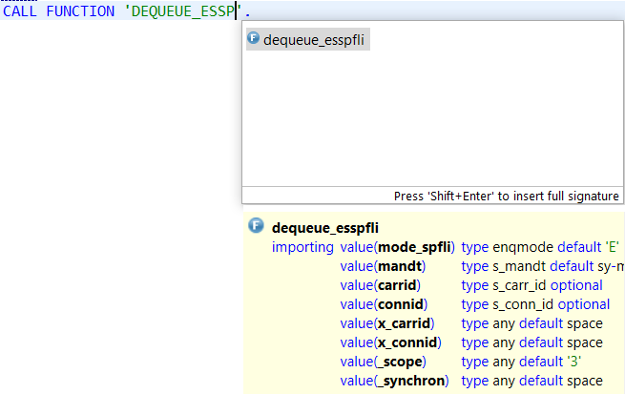

The parameters for the function call are very important as you have to specify the lock type ‘S’, the ‘CARRID’ and ‘CONNID’. Make sure you entered the correct parameters:
Unlock
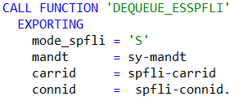
Now as you have unlocked the data set you are allowed to set an exclusive lock for changing the data set. Once again you use auto-completion function and insert the function call to create an exclusive lock. Right after the data modification you release the lock again. Your source code should look similar to this:
Source code
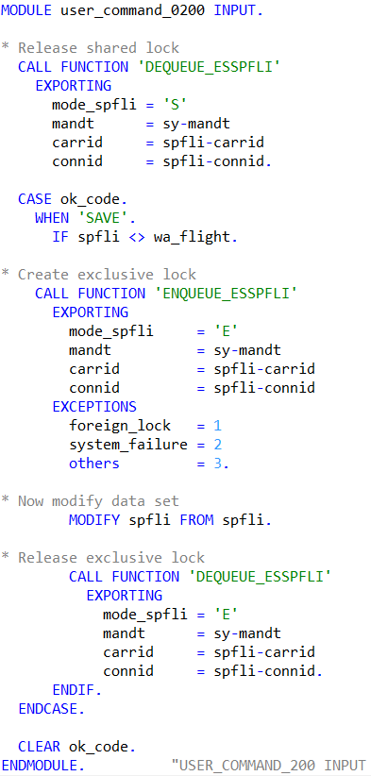
Save, check, activate
Please make sure you do not forget the point after each function call! Save, check and activate your program.

When testing your new program, you may monitor the creation of the shared lock in transaction SM12. When starting the transaction please enter the name of the table ‘SPFLI’ and hit the button ‘List’. You see a list of all your current existing locks.

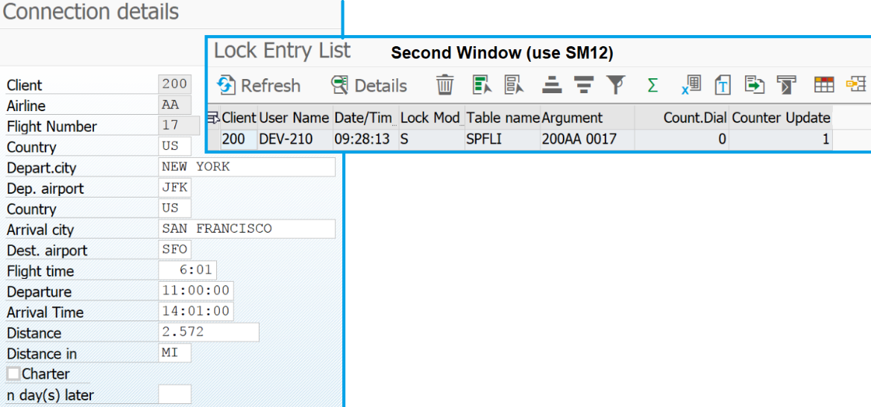

Challenge:
Short description: Extend your program in order to see an acquired exclusive lock when you call your program and open the screen to change the flight dates. Differentiate between view and change mode. Calling transaction SM12 within the SAP GUI will give you the opportunity to monitor current locks.

